2024 Wooden Nickel Corn Maze theme “Bigfoot”
Visit the Corn Maze page at www.WoodenNickelBuffalo.com for more information
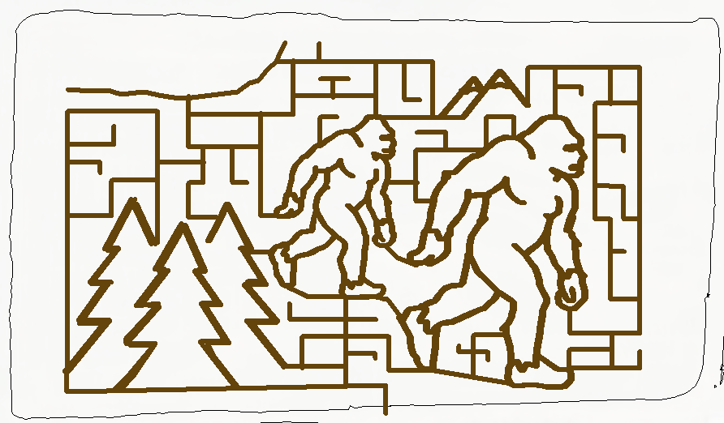
Corn Maze Open daily starting August 9. Come out and “Get Lost”!
Wooden Nickel Buffalo Farm 5970 Koman Rd Edinboro PA 16412
Call or text 814-734-2833 or mkoman164@gmail.com

